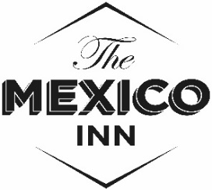
Nibbles

Whitebait - harissa mayonnaise 3.75
Greek Olives – (Halkidiki) 3.50
Grilled flatbread – garlic butter & parsley (v) 3.50

Chicken liver pâté – chutney, toast 5.00
Baker Toms’ baguette – salted butter (4 slices) 2.50
Curried cauliflower fritters (v) 3.50

Starter or Main course
A bowl of Monkfish & prawn scampi – crab cocktail mayonnaise, gem lettuce, lemon (starter) 9.50
Grilled sardine fillets– marinated tomato, green bean & salsa verde 7.50 or 14.50
Crispy duck – steamed pancakes, Asian-style dips, cucumber, lettuce 6.75 or 13.50
Grilled halloumi – beetroot relish, flatbread, chickpea chips, green chili jam, yogurt (v) 7.50 or 14.50
Main course
Traditional Newlyn market fish & chips - mushy peas, tartar sauce 13.50
Brisket & ale burger - swiss cheese, little gem, onion relish, pickles, hand cut chips 13.50
Grilled meatless burger – swiss cheese, little gem, onion relish, pickles, hand cut chips (v) 12.50
Rigatoni pasta – roasted tomato & fennel sauce, courgettes, feta, rosemary crumbs (v) 13.50
Grilled pork loin – creamed leeks, new potatoes, sage, apple sauce, jus 16.50
Grilled John Dory fillets – crushed potatoes, cherry tomatoes, fennel, aioli 17.50

Sides
Hand cut chips 3.50
Brisket topped chips 4.50
Mushy peas 2.50
Curry sauce – chip shop style 1.50
Dressed lettuce 2.50
Summer Beans – Lemon, parsley, olive oil 3.25

20% off for take -away food, bottle shop off sale drinks available (all for off premises
If you would like to discuss what is in our food, please ask. Our menu is prepared in house from fresh ingredients by a small team in an even smaller kitchen so please be patient at peak times. Thankyou.

